# Yolo Bypass Fish Monitoring Program: Water Quality Metadata

Document Number: DWR-6-MET-008

Version: 1.0

Status: Active

Effective Date: 1/21/22



California Department of Water Resources

Division of Environmental Services

3500 Industrial Boulevard

West Sacramento, California 95691

## Dataset Title

Interagency Ecological Program: Discrete water quality data from the Sacramento River floodplain and tidal slough, collected by the Yolo Bypass Fish Monitoring Program, 1998 - Present

## Abstract

The Yolo Bypass Fish Monitoring Program (YBFMP) operates a rotary screw trap and fyke trap and conducts biweekly beach seine and lower trophic surveys in addition to maintaining water quality instrumentation in the bypass*.* The YBFMP serves to fill information gaps regarding environmental conditions in the bypass that trigger migrations and enhanced survival and growth of native fishes, as well as provide data for IEP synthesis efforts. YBFMP staff also conduct analyses of YBFMP monitoring data to address pertinent management related questions as identified by IEP. The Yolo Bypass has been identified as a high restoration priority by the National Marine Fisheries Service and US Fish and Wildlife Service Biological Opinions for Delta Smelt, Winter and Spring-run Chinook salmon and by California EcoRestore. The YBFMP informs the restoration actions that are mandated or recommended in these plans and provides critical baseline data on the ecology of the bypass and how it interacts with the broader San Francisco Estuary. Only juvenile and adult fish catch with associated water quality are presented in this dataset. Our overall program objectives include:

1. Collect baseline data on water quality, chlorophyll, lower trophic level biota, and fish in the Yolo Bypass to monitor spatial and temporal changes in trends and abundance.
2. Analyze and communicate Yolo Bypass data with stakeholders and the scientific and management communities to address pertinent management related questions.
3. Provide technical expertise on Yolo Bypass aquatic ecology and monitoring and sampling methods.

Specifically, the objectives of the water quality monitoring are to:

1. Examine spatial and temporal trends in water quality.
2. Examine the relationship between water quality and biological observations.

We sample physical water quality discretely when conducting biological monitoring using a YSI ProDSS. Nutrient and chlorophyll data are taken biweekly along with lower trophic tows. Water is sampled at three sites along the Yolo Bypass and Sacramento River, then processed and analyzed by an internal DWR laboratory.

## Investigators

|  |  |  |  |  |  |  |
| --- | --- | --- | --- | --- | --- | --- |
| First Name | Middle Initial | Last Name | Organization | e-mail address | ORCID ID (optional) | Role in project |
|  |  | Interagency Ecological Program (IEP) |  |  |  | Creator |
| Nicole |  | Kwan | California Department of Water Resources | [Nicole.kwan@water.ca.gov](mailto:Nicole.kwan@water.ca.gov) | 0000-0003-1178-7788 | Creator, Associate, Data contact |
| Mallory | E | Bedwell | California Department of Water Resources | [mallory.bedwell@water.ca.gov](mailto:mallory.bedwell@water.ca.gov) | 0000-0001-9553-6032 | Database Manager, Field crew, Data contact |

## Other personnel names and roles

|  |  |  |  |  |  |  |
| --- | --- | --- | --- | --- | --- | --- |
| First Name | Middle Initial | Last Name | Organization | e-mail address | ORCID ID (optional) | Role in project |
| Nicole |  | Kwan | California Department of Water Resources | [Nicole.Kwan@water.ca.gov](mailto:Nicole.Kwan@water.ca.gov) | 0000-0003-1178-7788 | Creator, Associate, Data contact, Field crew |
| Jesse |  | Adams | California Department of Water Resources | [Jesse.Adams@water.ca.gov](mailto:Jesse.Adams@water.ca.gov) | 0000-0002-0739-8782 | Field crew |
| Mallory |  | Bedwell | California Department of Water Resources | [Mallory.Bedwell@water.ca.gov](mailto:Mallory.Bedwell@water.ca.gov) | 0000-0001-9553-6032 | Field crew |
| Naoaki |  | Ikemiyagi | California Department of Water Resources | [Naoaki.Ikemiyagi@water.ca.gov](mailto:Naoaki.Ikemiyagi@water.ca.gov) |  | Field crew |
| Catarina |  | Pien | California Department of Water Resources | [Catarina.Pien@water.ca.gov](mailto:Catarina.Pien@water.ca.gov) | 0000-0003-4427-6300 | Database Manager, Field crew, Data contact |
| JT |  | Robinson | California Department of Water Resources | James.robinson@water.ca.gov |  | Field Crew |
| Allison |  | Brady | California Department of Water Resources | [Allison.brady@water.ca.gov](mailto:Allison.brady@water.ca.gov) |  | Field Crew |
| Parisa |  | Farman | California Department of Water Resources | [Parisa.farman@water.ca.gov](mailto:Parisa.farman@water.ca.gov) |  | Field Crew |
| Emily |  | Hubbard | California Department of Water Resources | [Emily.hubbard@water.ca.gov](mailto:Emily.hubbard@water.ca.gov) |  | Field Crew |
| Brian | M | Schreier | California Department of Water Resources | [Brian.Schreier@water.ca.gov](mailto:Brian.Schreier@water.ca.gov) | 0000-0002-5075-3946 | Associate |
| Ted |  | Sommer | California Department of Water Resources | [Ted.Sommer@water.ca.gov](mailto:Ted.Sommer@water.ca.gov) |  | Associate |
| Louise |  | Conrad | California Department of Water Resources | [Louise.Conrad@deltacouncil.ca.gov](mailto:Louise.Conrad@deltacouncil.ca.gov) |  | Associate |

## License

This information is released under the Creative Commons license - Attribution - CC BY (<https://creativecommons.org/licenses/by/4.0/>). The consumer of these data ("Data User" herein) is required to cite it appropriately in any publication that results from its use. The Data User should realize that these data may be actively used by others for ongoing research and that coordination may be necessary to prevent duplicate publication. The Data User is urged to contact the authors of these data if any questions about methodology or results occur. Where appropriate, the Data User is encouraged to consider collaboration or co-authorship with the authors. The Data User should realize that misinterpretation of data may occur if used out of context of the original study. While substantial efforts are made to ensure the accuracy of data and associated documentation, complete accuracy of data sets cannot be guaranteed. All data are made available "as is." The Data User should be aware, however, that data are updated periodically, and it is the responsibility of the Data User to check for new versions of the data. The data authors and the repository where these data were obtained shall not be liable for damages resulting from any use or misinterpretation of the data. Thank you.

## Keywords

Yolo Bypass, San Francisco Estuary, Sacramento-San Joaquin Delta, Yolo Bypass Fish Monitoring Program, California Department of Water Resources, Interagency Ecological Program, tidal slough, water quality, nutrients, chlorophyll, cations, anions

## Funding of this work:

Funding is provided by the State Water Project.

## Timeframe

* Begin date: 2009-02-11
* End date: current
* Data collection: ongoing

## Geographic location

1. Yolo Bypass tidal slough and seasonal floodplain in Sacramento, California, USA.
2. North bounding coordinates (decimal degrees): 38.79395205
3. South bounding coordinates (decimal degrees): 38.23466149
4. East bounding coordinates (decimal degrees): -121.5368316
5. West bounding coordinates (decimal degrees): - 121.8073699

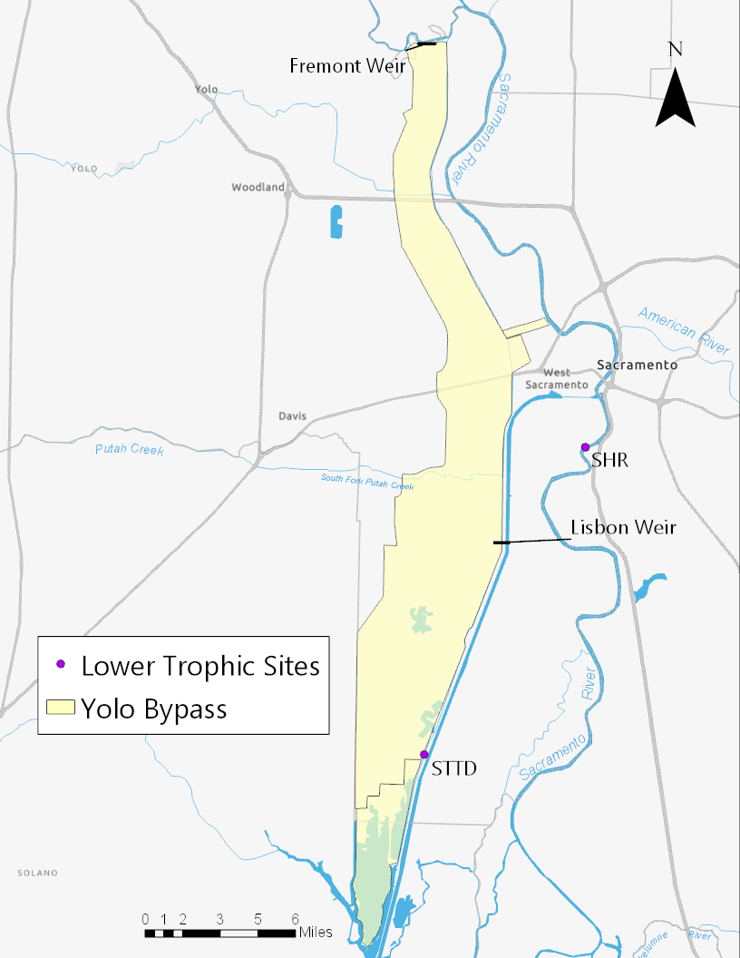

Water Quality Sites

|  |  |  |  |  |
| --- | --- | --- | --- | --- |
| # | Site Code | Location | Latitude | Longitude |
| 1 | LIS | Yolo Bypass Toe Drain Below Lisbon Weir | 38.47482 | -121.58858 |
| 2 | SHR | Sacramento River at Sherwood Harbor | 38.53188 | -121.528 |
| 3 | STTD | Screw Trap in Toe Drain | 38.35338 | -121.643 |

## Taxonomic species or groups

N/A

## Methods

Water Quality  
Water quality parameters are recorded at the start of each sampling event. Water temperature (degrees Celsius), electrical conductivity (microSiemens/cm), specific conductance (microSiemens/cm), pH, dissolved oxygen (mg/L), and turbidity (FNU) are sampled with a YSI ProDSS handheld meter. Turbidity values are averaged over three readings. Secchi depth is measured in the shade. Light attenuation (subsurface irradiance) is measured with a light meter (LI-COR LI-250A) at the surface, and at 75%, 50%, 25%, and 1% of the surface reference value in the water. The corresponding depth and measured micromoles are noted. Tide, condition of sampling (condition code), Microcystis level, and weather are also recorded with water quality parameters. Please see the YBFMP SOP on Lower Trophic Sample Collection for more details.

Water Collection and Filtration   
Water quality samples are collected using a van dorn. Collection bottles are rinsed three times with sample water before being filled and are stored in a cooler with ice while being transported to the laboratory for filtration.

For each sample of chlorophyll *a* and pheophytin *a*, between 80-500 mL of sample water is passed through a 47 mm diameter glass fiber filter with a 1.0 mm pore size at a pressure of 10 inches of mercury. After filtration, the filters are immediately frozen and transported to DWR’s Bryte Laboratory for analysis within 48 hours of collection (Standard Methods, 19th edition).

Orthophosphate (dissolved), dissolved nitrite + nitrate, dissolved organic nitrogen, dissolved calcium, dissolved chloride, total dissolved solids, and dissolved silica surface are filtered immediately after returning to the laboratory. The samples are filtered through a 0.45 µm pore size mixed cellulous ester membrane filter into one-pint polyethylene bottles, one of the bottles being an actual sample bottle turned into Bryte for analysis and the other being a designated filtration bottle which is rinsed between sites that are being filtered. The filtered water either remains in the one-pint sample bottle or is transferred from the designated filtration bottle to acidified half pint bottles (one with HNO3 and one with H2SO4). All waters samples are stored in the refrigerator and the chlorophyll filter samples are stored in the freezer. All samples are then transported to Bryte Laboratory within 48 hours for analysis.

Dissolved organic carbon (DOC) samples are filtered using a metal DOC filtration system. The samples are filtered through a 45 µm pore size mixed cellulous ester membrane filter. A glass flask is triple rinsed with DI and then 20-30 mLs of sample water are filtered and used to rinse the flask three times. Water is then filtered and transferred to a 40 ml glass vial that is pre-preserved with phosphoric acid.

Please see the YBFMP SOP on Lower Trophic Sample Collection for more details.

II. Sample Processing and TrackingSample Tracking  
Samples are tracked using an internal system called FLIMS. A chain of custody (COC) listing sample number, date, time, location, and study/project is sent to Byte Labs, who check that all samples are accounted for and turned in at the correct temperature. Signatures are required of both the person responsible for dropping off the samples, and the person receiving it.

Contractor  
*Since July 2009* (see historical changes for more information)  
DWR Bryte Labs

1450 Riverbank Road

West Sacramento, CA 95605  
916 376-1959  
<https://water.ca.gov/Programs/Environmental-Services/Water-Quality-Monitoring-And-Assessment>

### Quality Assurance and Control

#### Instrument Specifications

All YSI ProDSS instrumentation is specified in the ProDSS Manual.

All laboratory instrumentation is listed in the Bryte Lab Quality Manual.

Calibrations  
YSIs are calibrated for Specific Conductance, pH, Dissolved Oxygen, and turbidity monthly. YSI temperature readings are verified twice per year: once using a 5-point validation and once using a 2-point validation. Please see the YBFMP SOP on ProDSS Calibration for more detail.

Prior to sample analysis of conventional and inorganic constituents in water, external calibrations will be made using 3 - 5 standards that cover the range of sample concentrations. The lowest standard will be at or near the Method Detection Limit (MDL). Linear regression will be <0.995 or better. Calibration verification will be run after every 20 samples after the initial calibration and will use a standard source that is different from that used for the initial calibration. Acceptable recovery for conventional analytes is 80 - 120% and for inorganic analytes is 90 – 110%.

See Bryte Chemical Laboratory Quality Manual for additional details.

Replicates/Duplicates/Blanks

**Equipment blanks** - A blank is created for each day of sampling for a subset of nutrient samples, for a total of two equipment blanks. DI water is used to rinse sampling equipment, and then the equipment is filled with DI water and distributed for filtering or filling non-filtered bottles. Blanks are run for: dissolved ammonia, dissolved orthophosphate, dissolved nitrate + nitrate, total kjeldahl nitrogen, and total phosphorus.

**Replicates** - A replicate chlorophyll sample is taken for each site. The same amount of sample water as the parent sample is filtered to create this replicate sample.

**Laboratory Control Samples** – Laboratory control samples (LCS) provide bias information about a laboratory’s ability to perform acceptable analyses on a clean matrix with the chosen methods. The LCS will be prepared by the laboratory using an aliquot of the clean matrix (e.g., water, sediment, or tissue with no detectable levels of the target analytes) that is spiked with the analytes at known concentrations. The lab results must be within 80-120% recovery or control limits based on 3 times the standard deviation of a lab’s actual method recoveries for the target analytes to be acceptable.

**Matrix Spikes** – Matrix Spikes (MS) provide bias information on sample preparation and analysis. MS will be used to verify that the lab can determine if the sample matrix is causing either a positive or negative bias on sample results. MS samples will be prepared by the laboratory using an aliquot of the sample matrix (e.g., water sediment, or tissue) that is spiked with the analytes at known concentrations. The lab results must be within 80-120% recovery or control limits based on 3 times the standard deviation of a lab’s actual method recoveries for the target analytes to be acceptable.

**Matrix Spike Duplicates** – Matrix spike duplicates (MSD) provide precision information on sample preparation and analysis. The laboratory will prepare separate spiked matrix samples (MS) for analysis. Acceptable lab results for bias are the same as described for matrix spikes. The duplicate values must have a RPD of less than 25% to be acceptable.

**Laboratory Duplicates** – Laboratory duplicates provide precision information on the analytical methods with the target analytes. The laboratory will generate the duplicate samples by splitting one sample into two parts, each of which will be analyzed separately. The duplicate values must have an RPD of less than 25% to be acceptable.

Data Quality Control  
Three levels of quality control are conducted on field data:

1. Field data are checked by someone other than the data recorder prior to leaving each field site
2. Datasheets are checked while being entered into the Microsoft Access database, which has customized error-checking and data validation checks,
3. A separate DWR staff member compares data from original field sheets to data entered into the database

DWR’s Field and Laboratory Information Management System (FLIMS) is used to track water quality field and lab data from collection in the field to final use and storage. Prior to each monthly water quality run, FLIMS is used to generate the paperwork (sample identification numbers, labels, chain of custody sheets, etc.) for each field run. The data collected in the field is recorded on field sheets and is typically entered into FLIMS the next day or before samples are submitted to Bryte Lab. Staff at Bryte Lab enters laboratory data directly in FLIMS that is uploaded to the Water Data Library (WDL) when all the data for one field day has been entered. If there is missing field and lab data, discrepancies between data on field sheets and WDL, or the data does not meet quality objectives, the Lower Tropic Lead is notified and corrections are made, or the data is flagged appropriately.

Notes on Data Quality:   
Please see the historical changes section for changes in sampling methods.

### Archiving

Samples are disposed of once analysis is complete.

Data can be accessed on the Department of Water Resources Water Data Library:

<https://wdlbeta.water.ca.gov/Map.aspx>

### Calculations and Analysis

None

### Historical Changes

* *Methods:*
  + From May 2019 until November 2020: 0.45 µm MCE filters used for nutrient filtration (NO2+NO3, O-Phos, NH3, DON) were soaked in DI water for at least 4 hours before use. The water was changed after filters had soaked for an hour, and the hour soaking was repeated a total of 4 times.
  + 11/19/20: Bryte updated preservation methods for some constituents. TKN, TPhos, NO2+NO3, O-Phos, NH3, and DON were previously stored in unacidified half pint bottles and frozen. The new protocol is to add 250 mLs of sample water into a bottle with H2SO4 and to store at 5°C.
  + June 2021- creation of the blank sample water was standardized. Previously a sample of DI from the lab faucet was filtered. Now the DI is passed through whichever sampling vessel was used (churn splitter or van dorn) and then added to a designated blank 1L Nalgene bottle.
  + June 2021- the filter used to filter the DOC sampled changed from a combusted 1 µm glass fiber filter to a 0.45 µm MCE filter. Use of a glass filtering flask and a vacuum pump was also added to the DOC filtering protocol.
  + October 2021- water grabs in the field are now standardized to use the van dorn in order to take a homogenized sample.

### Review Processes

None

### Methods References

| **Reference Location or DOI** | **Reference Title** |
| --- | --- |
| AEU | DWR-6-SOP-024_v1.1_YSIProDSSCalibration |
| AEU/Bryte | DES-1-MNL-001 Bryte Lab Quality Manual version 4.0 |
| AEU | DWR-6-SOP-015_v1.7_LowerTrophicSampleCollection |

## Data Table

**Table name:** Water Data Library Data Export Table

**Table description:** A description of the table exported from Water Data Library which contains data from the Yolo Bypass Fish Monitoring Programs Water Quality Measurements

| **Column name** | **Description** | **Unit or**  **code explanation or date format** | **Missing value code** |
| --- | --- | --- | --- |
| Data Owner | A code that refers to which group took the data |  |  |
| Data Status | Indicates whether the data has been reviewed or made public |  |  |
| Long Station Name | Full name of the sampling site in FLIMS |  |  |
| Short Station Name | Abbreviated name of the sampling site in FLIMS |  |  |
| Station Number | Number associated with the sampling site in FLIMS |  |  |
| Sample Code | Sample number associated with each site and sampling occasion in FLIMS. All constituents from the same site on the same occasion have the same number. |  |  |
| Collection Date | Date and time the sample was collected | dd/mm/yyyy 00:00 |  |
| Analyte | The constituent being measured |  |  |
| CAS Reg Number | Chemical Abstracts Service registry number |  |  |
| Result | Amount of constituent measured by Bryte Lab |  |  |
| Rpt Limit | Reporting limit of analysis method used by Bryte Lab |  |  |
| Units | Units that the constituent was measured in | degreeCelcius, milligramsPerLiterasNitrogen, milligramsPerLiter, milligramsPerLiterasCarbon, milligramPerLiterasPhosphorus, microsiemensPerCentimeterat25DegreesCelcisus,  milliliter, microgramsPerLiter |  |
| Method | Analysis method used for measuring constituent |  |  |
| Depth | Depth at which sample was taken | Zero meters indicates a surface grab |  |
| Matrix | What type of sample was analyzed |  |  |
| Sample Type | Indicates if the sample was the main sample or a replicate sample |  |  |
| Parent Sample | If the sample is a replicate, this indicates the sample code of the parent sample |  |  |
| Description | unused |  |  |
| Notes | Indicates if Bryte Lab ran a spiked or duplicate sample for QA/QC |  |  |
| Results Rejected | Indicates if results were rejected | N = no, - = results were not rejected because Analyte is a field measurement |  |

## Articles

| **Article DOI or URL (DOI is preferred)** | **Article title** | **Journal title** |
| --- | --- | --- |
| 10.15447/sfews.2018v16iss1/art3 | Physical and Biological Responses to Flow in a Tidal Freshwater Slough Complex. | San Francisco Estuary and Watershed Science |

## Scripts/code (software)

| **File name** | **Description** | **Scripting language** |
| --- | --- | --- |
| None |  |  |

## Notes and Comments

None

### Versioning History

* *List versions in chronological order.*
* *Start with v1.0 for the first approved, effective version. For edits and changes, increase by 0.1 (v1.1, v1.2). When the edits are approved and the new version is made effective, increase the version number by the next whole number. Add more rows as needed.*
* *Update the name of the file with the new version number.*
* *Save archived versions in a shared internal folder.*
* *Make sure to communicate updated versions to relevant staff or other audiences.*
* See “Revision History” section for an example of a complete table

| **Version number** | **Date created** | **Description of changes** | **Justification for change** | **Version editor(s)** | **Contact info** |
| --- | --- | --- | --- | --- | --- |
|  |  |  |  |  |  |
|  |  |  |  |  |  |
|  |  |  |  |  |  |
|  |  |  |  |  |  |

## Appendix

*Include here additional materials you think relevant – flow charts, datasheets, templates/forms.*

-END OF DOCUMENT-

## Versioning History

| **Version number** | **Date created** | **Description of changes** | **Justification for change** | **Version editor(s)** | **Contact info** |
| --- | --- | --- | --- | --- | --- |
| 1.0 | 1/21/22 | New Effective version | New Document | Mallory Bedwell | [Mallory](mailto:Johnfranco.saraceno@water.ca.gov).Bedwell@water.ca.gov |